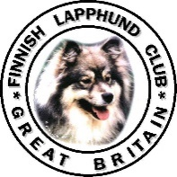 | Versatility Awards Claim Form  Please attach documentary proof of each claim - copies or scans!  This document was reformatted 3rd November 2021.
Please Print Clearly

Name of Owner(s)
Street Address
Town |  |  | Post Code
Phone Number |  |  | Mobile Number
Email Address
Name of Handler if Different from Owner
Is the Handler a Junior? (Please circle) |  | Yes |  | No

Dog’s KC Registered Name
Dog’s Pet Name |  | Date of Birth

Claimed Points
Details of Achievement | Discipline/Category | Points Claimed

In Discipline/Category please choose from the relevant category

S | (Showing) | O | (Obedience) | T | (Working Trials) | H2M | (Heelwork to Music)
A | (Agility) | R | (Rally) | GC | (Good Citizens) | AC | (Assistance / Character)
H | (Hoopers)
Please only enter one category per row

Please return this form along with copies of documentary proof of claim to
Sheila Hall, 90 Clarendon Street, Dover, Kent, CT17 9RD email: sambreeze.sheila@gmail.com

